**BRM Lab 9**

**Introduction to selenium and small project  
 1. Frist adding Selenium chrome extension to chrome browser   
2. Open the tool and follow the steps**

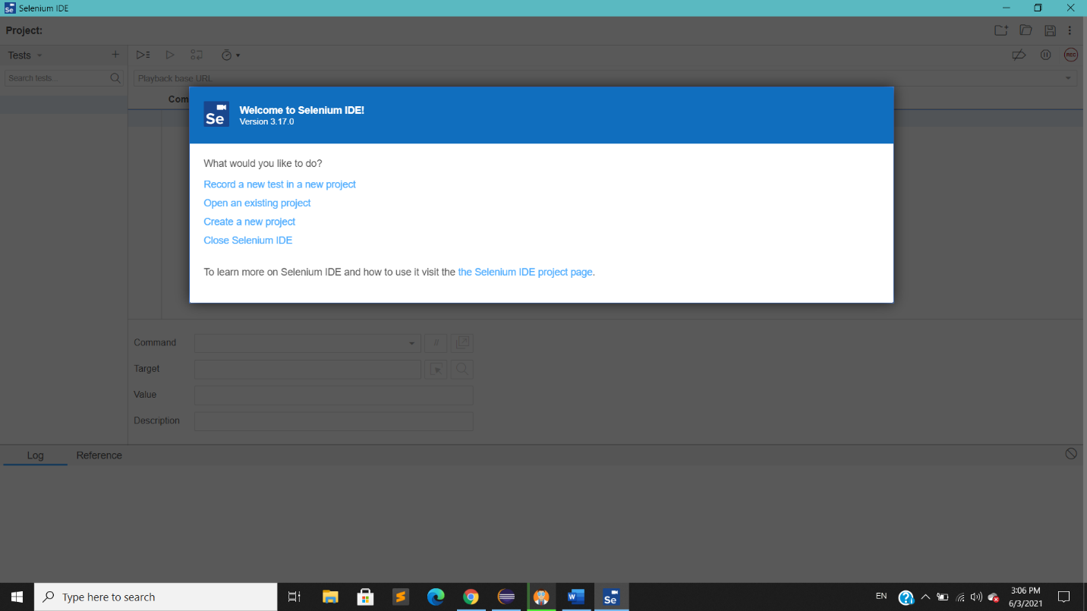

**3.Provide the URL on which test will run**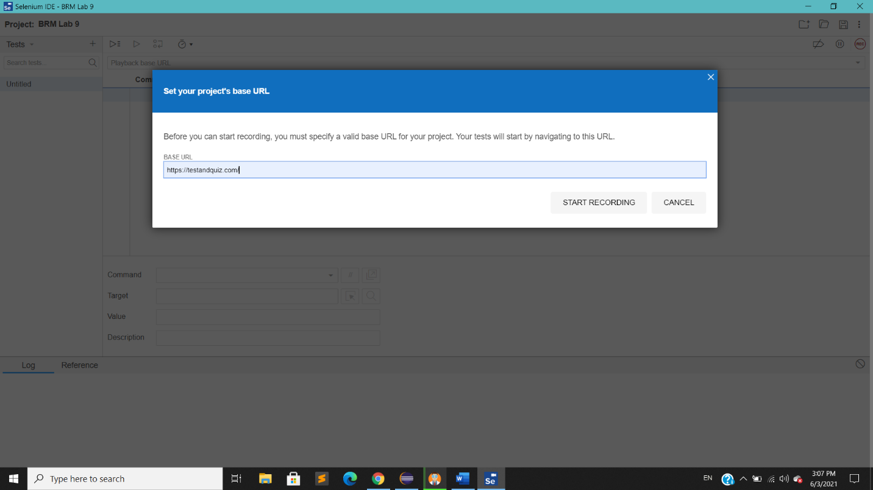

**4. This page show all process done on browser  
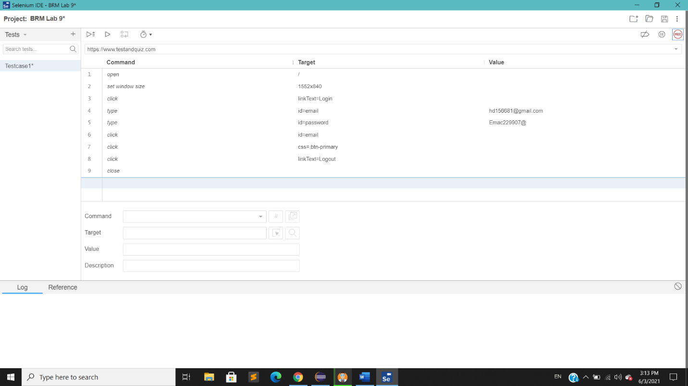**

**5 . Now Stop recording tab provided**

**6. Now provide relatable name to our project**

**7. Now Run the test by clicking button provided on top left corner**

**8. After all successful run, bottom down shows the status of the test**

